­­­­­­­­­­­­­­­­­­­­­­­­­­­­­­­­ABSTRACT

India is an agricultural country, and hence a lot of water is required for farming. Water should be used in a proper way. We propose a microcontroller-based system for automatic drip irrigation. We make use of the sensor like soil moisture sensor, to keep a check on the amount of water used. By this project we can control the moisture content of the soil in the cultivating field. The water flow will be monitored and based on the data available, analysis and prediction will be done. This will help the user to use water wisely in future. As the method of dripping will reduce huge water losses it became a popular method by reducing the labor cost and increasing the yields. When the components are activated, all the components will read and gives the output signal to the controller, and the information will be displayed to the user (farmer). The aim of the implementation this project was to demonstrate that the automatic plant irrigation can be used to reduce water use and save your time. There are many systems are available to water savings in various crops, from basic ones to more technologically advanced ones. For instance, in one system plant watering status was monitored and irrigation scheduled based on temperature presents in soil content of the plant. In this project, troubleshooting mechanism is also provided i.e. during every occurrence of error, an email and SMS will be sent by IFTTT services. The conditions applied for sending email are, Sensor Failed (indicates: sensed value is less than 500 for more than 5 times); NAN (Not A Number) sensed (indicates: connection problem); Empty Tank (indicates sensed value is 4095 for more than 20 times). For all these problems, an email will be sent to the email specified during registration of farmer/user, in order to make them aware of the problem occurred.

Keyword’s: NODE MCU ESP32S (DEV KIT V1), Soil moisture Sensor (YL-69), Relay, Submersible motor, 6F22 9V Battery, Potentiometer.

CHAPTER NO. 1

“INTRODUCTION”

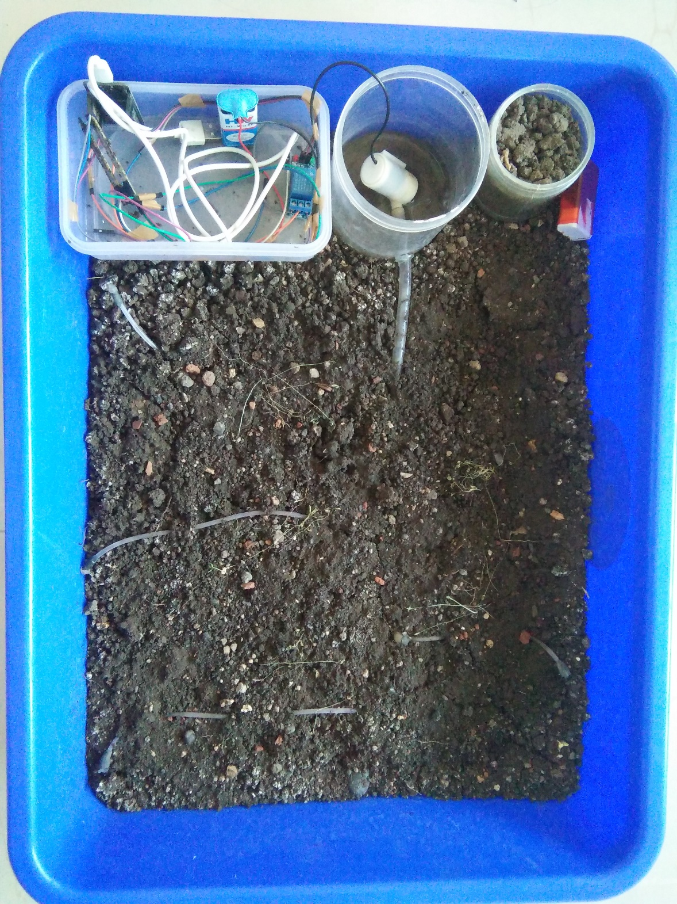

1. INTRODUCTION

India is an agricultural country where 60-70% economy depends on agriculture, the modernization of the conventional agricultural practices for the better productivity is must. Day by day water is getting depleted due to unplanned use of water. And hence, the ground water level is decreasing. Lack of rains and scarcity of land water also results in decrement in quantity of water on earth. In present days, in the field of agriculture farmers are facing major problems in watering their crops. It’s because they don’t have proper idea about the availability of the power. Even if it is available, they need to pump water and wait until the field is properly watered, which compels them to stop doing other activities – which are also important for them, and thus they loss their precious time and efforts. The current trend is toward switching from a manual system to automatic operations in a pressurized system which is energy saving, reduced labor cost and control in fertilizer application are among some of the major advantages in adopting automated techniques in drip irrigation system. This automatic drip irrigation system senses the moisture content of the soil using YL-69 sensor and then nodemcu32s microcontroller will fetch the data from ThingSpeak server and compare the input data with the threshold value. If the soil moisture goes down then automatically motor will start and amount of water required will be provided to the particular crop. A proper usage of irrigation system is very important because the main reason is the shortage of land reserved water due to lack of rain, unplanned use of water as a result large amounts of water goes waste. For this reason, we use this automatic crop watering system, and this system is very useful and efficient in all climatic conditions and reduce human error, facilitate high frequency and low volume irrigation. In drip irrigation system the drips are placed near the surface of the ground where the water reaches to the root zone of the crop. The objective of the system is to a) Water resources b) Handles the system automatically c) Detects the level of water d) Based on the data available, analysis and prediction will be done e) Builds such system which enhances crop productivity. Also, troubleshooting mechanism is given with particular detection of error. Whenever a problem/error is detected, an email will be sent through IFTTT services to the farmer’s email-id which he will be using while registering his form. This Project also contains a website (Project UDBHAV), which will enable farmer/user to fill the registration form, if they have to implement AODI in their field. It will also contain some static information regarding this project.

* 1. OBJECTIVES:

1.It reduces the amount of water used during irrigation by using soil moisture sensor.

2. It provides automatic switching of motor thus reduce man power.

3. It provide appropriate amount of water to every crop by sensing data

4. It provides embedded system which will make our product easy to use for the farmer.

5. We improved our communication skills while doing surveys for data gathering.

6. It supports troubleshooting mechanism.

CHAPTER NO.2

“LITERATURE SURVEY”

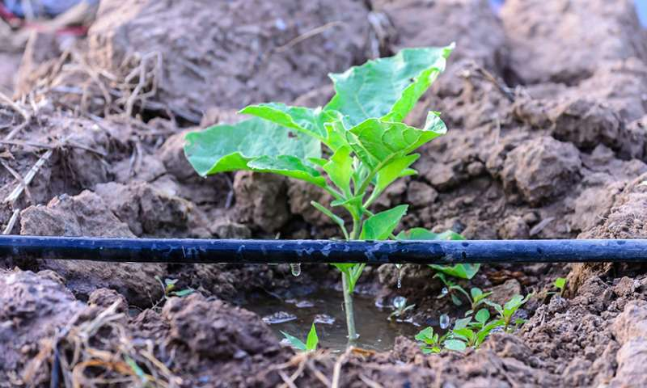

2.1 IRRIGATION DEPARTMENT:

In the Irrigation Department, Mr. Aashish T. Deogade, Superintending Engineer, has provided us the information about water and soil moisture requirement. They also provided us the information about life stages of crops and changes in the water requirement of crop according to changing stage. Mr. Vinay Munne, Junior Engineer of Irrigation Department, has provided some of the information related to their previous project which includes annual crop water requirements according to changing stages. Some written information was provided which became helpful in calculating the water requirement of particular crop in specific area. They also share their experience which paved a way to our project.

2.2 AGRICULTURE DEPARTMENT:

In the Agriculture Department, Mr. Durge has provided us the information about the implementation of automation of drip irrigation. Also, the alternatives to achieve the automation other than using motor and sensor. Many of the Professors of Agriculture Department provided a way and a direction to which project should be moved. Here, we get to know that, every crop requires different water according to its different life stage. As crop’s life stage moves ahead, a greater amount of water is needed to the crop.

2.3 JAIN IRRIGATION DEPARTMENT:

In the Jain Irrigation Department, Mr. Uday provided us with the information of existing automation system i.e. existing automation system is based on Time Limitations. Automation system with soil moisture content have not been achieved till now. The process is going on to achieve this goal. They doesn’t provided us the actual soil moisture requirement as it was a confidential information, but has given a formula from which it was quite easy to find out the soil moisture requirement. They directed us towards the difference of existing automation system and future automation system. They greatly supported us in our project and has given a way to move it further.

2.4 MDB ELECTROSOFT:

In the MDB Electro soft, Mr. Mangesh Bharti provided us the information about the microcontroller to be used. They guided us that, using Arduino will be inaccurate, using raspberry-pi will increase the cost. So, NODE MCU ESP32S will be the best option to be used. This microcontroller has inbuilt WI-FI module and inbuilt temperature and humidity sensor. They also helped us in finding the errors, on which we were stuck from almost 25 days (i.e. Fatal error). They guided us the way to use electronics components with the software, and suggested to use Arduino software with ESP32s microcontroller. Using motor instead of valve was suggested by Mr. Akshay and Mr. Prem, teachers and learners of MDB ELECTROSOFT. They suggested that, to implement automation on small scale requires motor while on large scale requires solenoid valve.

2.5 OTHER SURVEY’S:

One of the meet was with Mr. Bhonde, who provided us the information about the additional components of drip irrigation. This additional components include Filters, Drippers, Small Pipes, etc. They provided us a well proved picture of working of drip irrigation, which help us in making or AODI model. Another meet has been done with Patel Electronics, from where we get to know the input and output pins of microcontroller.

CHAPTER NO. 3

“METHODOLOGY”

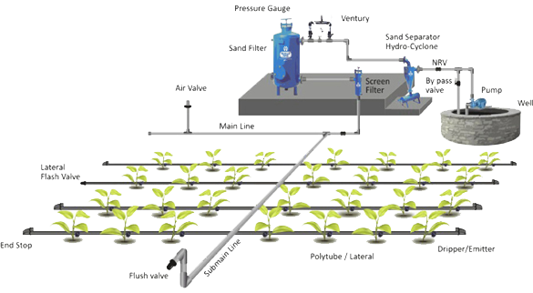

3.1 DATA REQUIRED FOR AODI:

The following data is required for planning and analyzing AODI System:

1. Soil Moisture of crops
2. Water requirements of crops
3. Stages in Life-time of crop
4. Water availability
5. Existing Irrigation system
6. Working of YL-69 and ESP32s
7. Services from IFTTT
8. ThingSpeak Server.

3.2 WORKING:

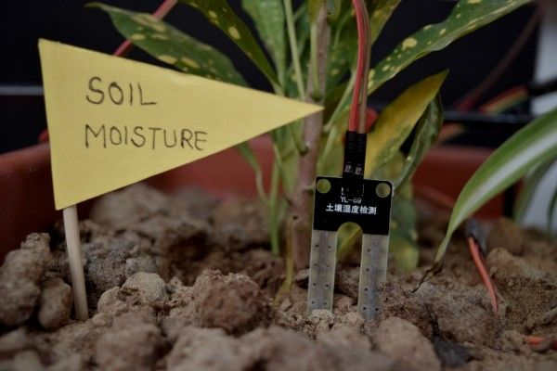

Figure 1 MODEL OF AODI.

An automatic plant watering system using NODEMCU microcontroller ESP32S is programmed such that it gives the interrupt signals to the motor via the relay. Soil moisture sensor is connected to the D13 pin to the Dev kit of ESP32S which senses the moisture content present in the soil. Whenever the soil moisture content values go down, the sensor senses the moisture change, giving signal to the microcontroller so that the pump (motor) can be activated. A new value is sensed by every 16 seconds. During any occurrence of error, an email will be sent to the farmer’s email-id so that he will be aware of the problem. This concept can be used for automatic plant watering system. The circuit comprises an NODEMCU ESP32S,

a soil moisture sensor, a 12V motor pump, a relay, a battery and a potentiometer. This automatic drip irrigation system senses the moisture content of the soil using YL-69 sensor and then nodemcu32s microcontroller will fetch the data from ThingSpeak server and compare the input data with the threshold value. According to the sensed value, relay with give output to motor through pin D2. The output received by motor will in turn keep the motor on or off. If sensed moisture is less than threshold value, then relay will give output to motor and motor accordingly will be started and Suppose, if sensed moisture is greater than threshold value, relay’s output will off the motor. Here, ThingSpeak server is used for analyzing and retrieving the sensed value of crop. Another reason for using server is for the sake of troubleshooting and as it is an embedded system so database is not maintained here. The troubleshooting mechanism is provided by sending an email to the email-id provided at the time of registration. Project’s website will enable farmer to register his information in order to implement AODI in their field. This website will also contain a static information so that the user will get to know the sole purpose of automation of drip irrigation. Here, Email will be sent according to conditions specified in applets created in webhooks service of IFTTT. Applets are created on if this then that condition, for example: if sensor failed then send me an email at specified email-id. Email will be sent to the farmer on the specific conditions such as:

* Sensor Failed (sensed value will be less than 500 for more than 5 times)
* Empty Tank (sensed value is 4095 for more than 20 times)
* NAN i.e. Not A Number (loose connection or connection error)

3.3 BLOCK DIAGRAM:

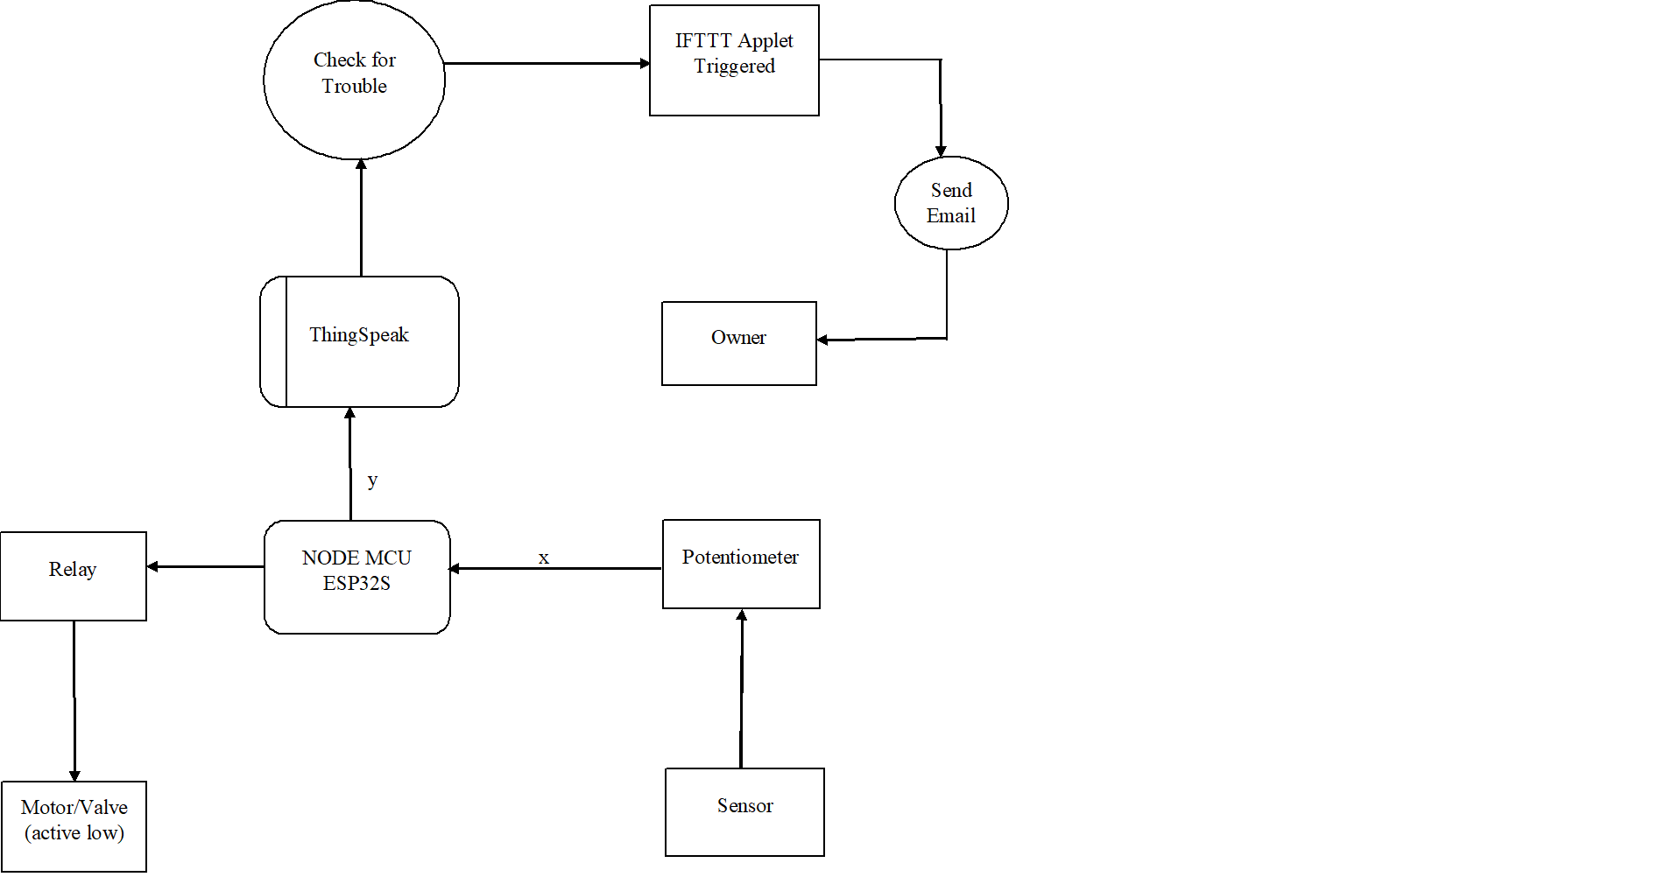

Figure 2.DATA FLOW DIAGRAM

The above block diagram represents a soil moisture sensor i.e. YL-69 which sense the moisture of soil, a potentiometer i.e. YL-38 which works as intermediary between sensor and esp32s board. As, sensor gives output in voltage, potentiometer converts this output to readable form which can be understood by esp32s board. ThingSpeak server is used for proper analyzing of data, troubleshooting, maintaining watering according to threshold. NODEMCU ESP32S is the main component for processing the data. A relay which acts in between motor and esp32s board in order to give output to motor. A motor for watering crops according to its moisture and water need.

3.3.1 NODEMCU ESP32S:

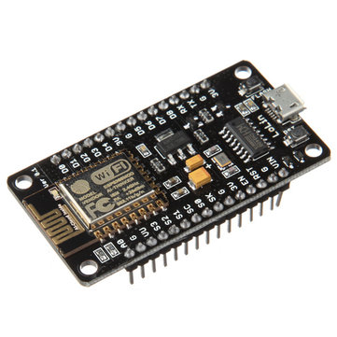

Figure 3.NODE MCU ESP32S

NodeMCU is an open source [Lua](https://www.lua.org/) based firmware for the [ESP32](http://espressif.com/en/products/hardware/esp32/overview) and [ESP8266 WiFi SOC from Espressif](http://espressif.com/en/products/esp8266/) and uses an on-module flash-based [SPIFFS](https://github.com/pellepl/spiffs) file system. NodeMCU is implemented in C and is layered on the [Espressif ESP-IDF](https://github.com/espressif/ESP-IDF).

The firmware was initially developed as is a companion project to the popular ESP8266-based [NodeMCU development modules](https://github.com/nodemcu/nodemcu-devkit-v1.0), but the project is now community-supported, and the firmware can now be run on any ESP module.

Support for the new [ESP32 WiFi/Bluetooth SOC from Espressif](http://www.espressif.com/en/products/hardware/esp32/overview) is under way.

3.3.2 SOIL MOISTURE SENSOR(YL-69):

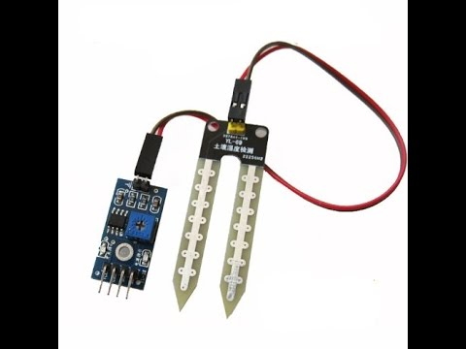

Figure 4.SOIL MOISTURE SENSOR

This soil moisture sensor can be used to detect moisture to activate a display or trigger an action. When the soil is dry, the module output is set high, when wet low.

Use this sensor make an automatic watering system, to keep your garden plants well without anyone having to manage them.

Usually sold as two parts: a fork-shaped moisture probe with two connections and a module board with 2 connections for the probe and 4 connections:

* VCC
* GND
* D0
* A0

3.3.3 POTENTIOMETER(YL-38):

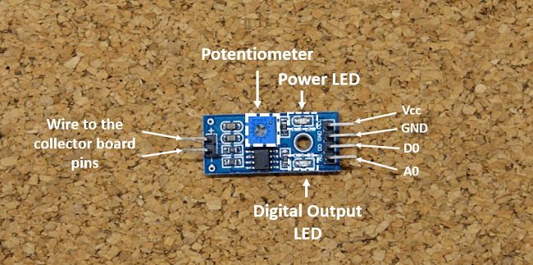

Figure 5.POTENTIOMETER YL-38

YL-38 works as interface for YL-69 probes. The sensor comes with small PCB board fitted with LM393 comparator chip and potentiometer. Output signal pins (both analog and digital). Input pins for the sensor is also present on this PCB. The YL-38 ranges from 0 to 45% volumetric water content in soil. It operates on 3mA at 5v DC. Its operating temperature is from -400C to +600C.

3.3.4 RELAY:

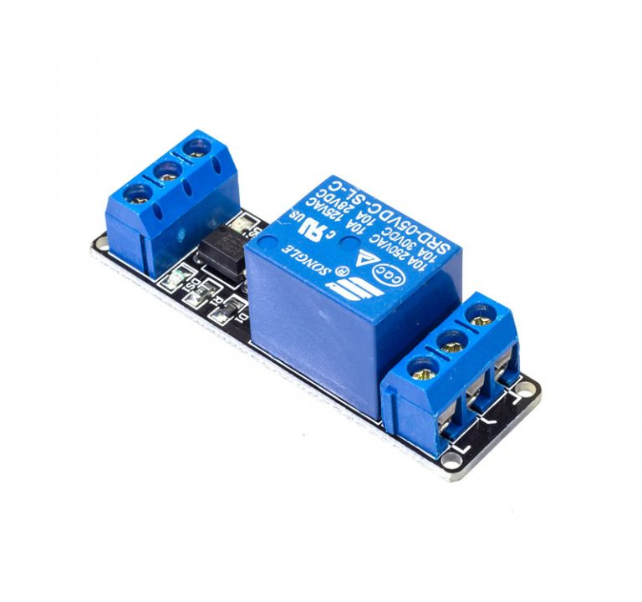

Figure 6. RELAY

A **relay** is an electrically operated switch. Many relays use an electromagnet to mechanically operate a switch, but other operating principles are also used, such as solid-state relays. Relays are used where it is necessary to control a circuit by a separate low-power signal, or where several circuits must be controlled by one signal. The first relays were used in long distance telegraph circuits as amplifiers: they repeated the signal coming in from one circuit and re-transmitted it on another circuit. Relays were used extensively in telephone exchanges and early computers to perform logical operations.

3.3.5 MOTOR:

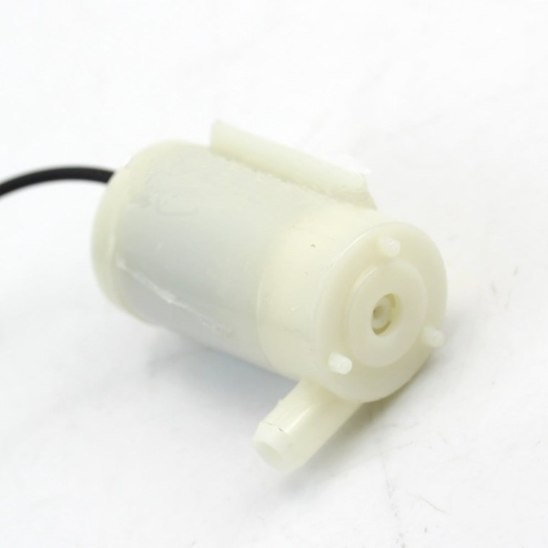

Figure 7. MOTOR

A submersible pump (or sub pump, electric submersible pump (ESP)) is a device which has a hermetically sealed motor close-coupled to the pump body. The whole assembly is submerged in the fluid to be pumped. The main advantage of this type of pump is that it prevents pump cavitation’s’, a problem associated with a high elevation difference between pump and the fluid surface. **Small DC Submersible water pumps**push fluid to the surface as opposed to jet pumps having to pull fluids. Submersibles are more efficient than jet pumps.

3.3.6 THINGSPEAK SERVER:

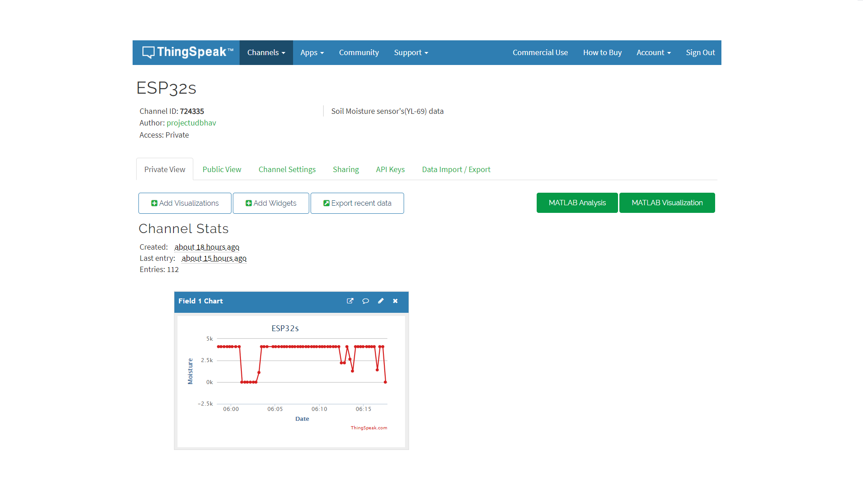

Figure 8. THINKSPEAK SERVER

**ThingSpeak** is an [open-source](https://en.wikipedia.org/wiki/Open-source_software) [Internet of Things](https://en.wikipedia.org/wiki/Internet_of_Things) (IoT) application and [API](https://en.wikipedia.org/wiki/API) to store and retrieve data from things using the [HTTP](https://en.wikipedia.org/wiki/HTTP) protocol over the Internet or via a Local Area Network. ThingSpeak enables the creation of sensor logging applications, location tracking applications, and a social network of things with status updates.

3.3.7 IFTTT:

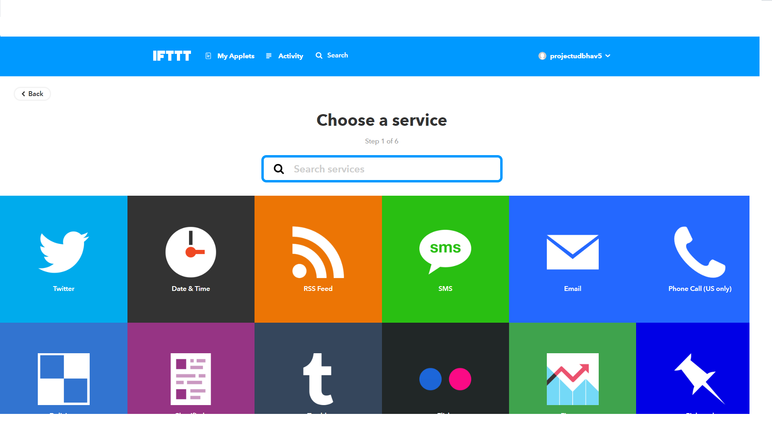

Figure 9. IFTTT SERVICES

# IFTTT is a free platform that helps you do more with all your apps and devices. It uses different services which can email, text or can tweet. IFTTT uses applets which are designed to make use of specific service. In this project, we have created 3 applets for webhooks service as shown below:

# 

Figure 10.APPLETS FOR AODI.

In the above fig, 3 applets are shown which will conditionally send an email or SMS to the specified email-id or mobile number. Applets are created on if this then that condition as shown, if “sensor_failed” then send me an email at projectudbhav5@gmail.com.

3.3.8 WEBHOOKS:

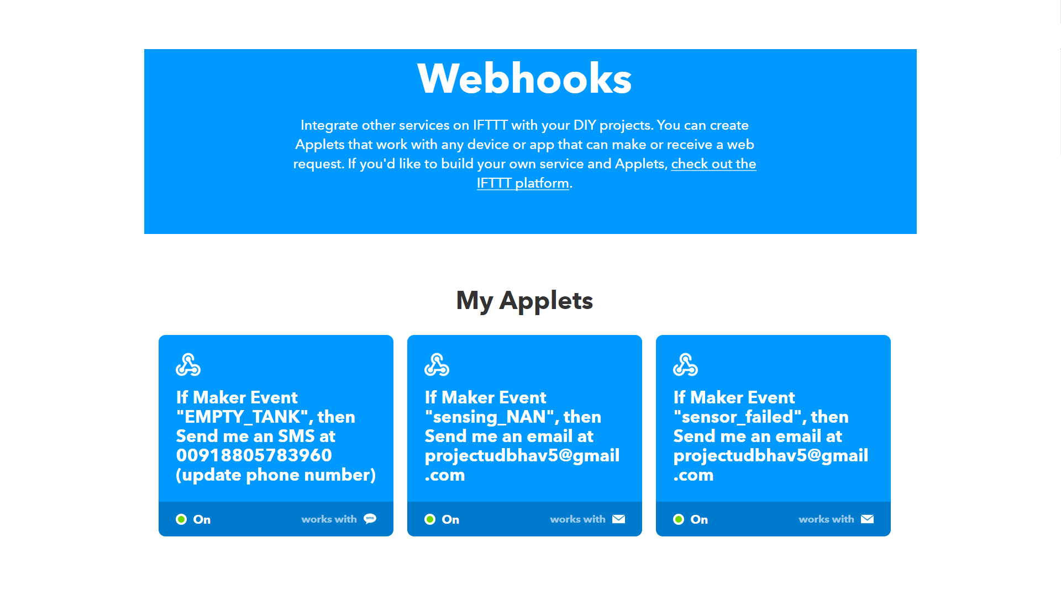

Figure 11.WEBHOOKS.

A **Webhooks** is an HTTP callback: an HTTP POST that occurs when something happens; a simple event-notification via HTTP POST. A web application implementing **Webhooks** will POST a message to a URL when certain things happen.

3.4 COSTS AND FUNDING:

COST OF DRIP IRRIGATION DEPENDS ON:

1. Size and shape of land
2. Type of Soil
3. Terrain
4. Types of crop
5. Sowing pattern
6. Subsidy given by government (according to category).

DRIP IRRIGATION COST IN INDIA:

Installation cost depends on various factor such as, etc. “For a farmer wants to install drip irrigation for say orange farming in which plants are 3 meters apart it will cost him about Rs. 55,000 per acre. For crops or plants which are planted in 6X6 pattern drip irrigation cost only about Rs. 35,000 per acre.” said SK Pal of Jain Irrigation. ***In nowadays the cost of drip irrigation in India varies from 45000–60000 Indian rupees.***

FARMER’S ELIGIBILITY:

* 16.05% of the total financial target shall be covered by schedule caste farmers;
* 9.55% of the total financial target shall be covered by schedule Tribes farmers.
* Not less than 25% of total financial target shall be covered by BC farmers;
* Not less than 50% of the total financial target shall be covered by SF/MF farmers;
* Not exceeding 10% of financial target shall be covered by other farmers (more than 5 acres land holding).

CHAPTER NO. 4

“SYSTEM IMPLEMENTATION”

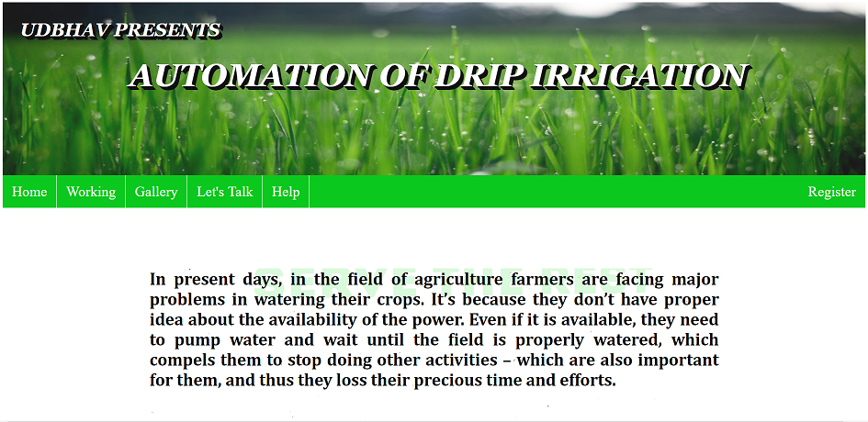

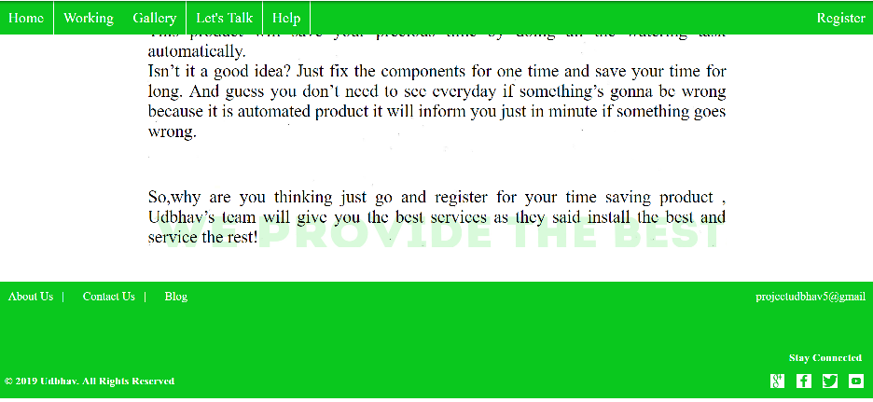

Our web-based application starts with an “HOME”, which allows the user/farmer to get to the importance of AODI. This page contains menus to get navigate to other pages of website. The first tab navigates to the “WORKING” of AODI, containing the whole working of system as well as components used. Also, a video to get into the detail of the working. The second tab navigates to the “GALLERY” of the project which includes all the pictures of the components and model of AODI. The third tab navigates to the “LET’S TALK”, which will allow the farmer to communicate with other farmers or experts. Any query or suggestion related to AODI can be commented in the comment box, just like a real time messaging system. Any user/farmer can refer to other’s query and give solution. By this feature, experts will be able to know, what type of queries farmer can come with. The next tab navigates to “ABOUT US”, which will include all the information about developers with their contacts enabling a user to contact any of the developer when needed. The next tab navigates to “CONTACT US”, includes email-id, location and mobile number of project UDBHAV. This will help user to contact, if they want to implement AODI in their field. The next and most important tab for user is “REGISTER”, allows a user to register the form, if they wish to implement automation of drip irrigation. This form accepts information of farmer including Full Name, Phone No., Email-Id, Address, Crop you are growing, Are you using drip irrigation? Area used to

grow crop. Once registration is successful, pop-up message will be displayed showing “Your Registration is Successful. Hope we’ll meet soon”. After successful registration, farmer can contact developers or can mail at [projectudbhav5@gmail.com](mailto:projectudbhav5@gmail.com) to know the cost of whole implementation and apply this automation in their field. The next tab navigates to “HELP” which includes three options, Research Paper; FAQ’s; Community Forum. Research Paper will navigate you to the pdf’s related to every information regarding automation. FAQ’s i.e. Frequently Asked Questions, navigates to the questions and their answers that are most frequently asked by the farmers. Questions with their relative answers are given. Community Forum will navigate you to Let’s Talk section of the website. One of the tab of website is only applicable for Admins. This section includes all the information which is needed by Admins, i.e. Registered users, their information, their contact list and so on. This section is not visible to any of the user of website, only to the admins of the website. Our website will not contain any URL for this section.

CHAPTER NO.5

“PRELIMINARY DATA”

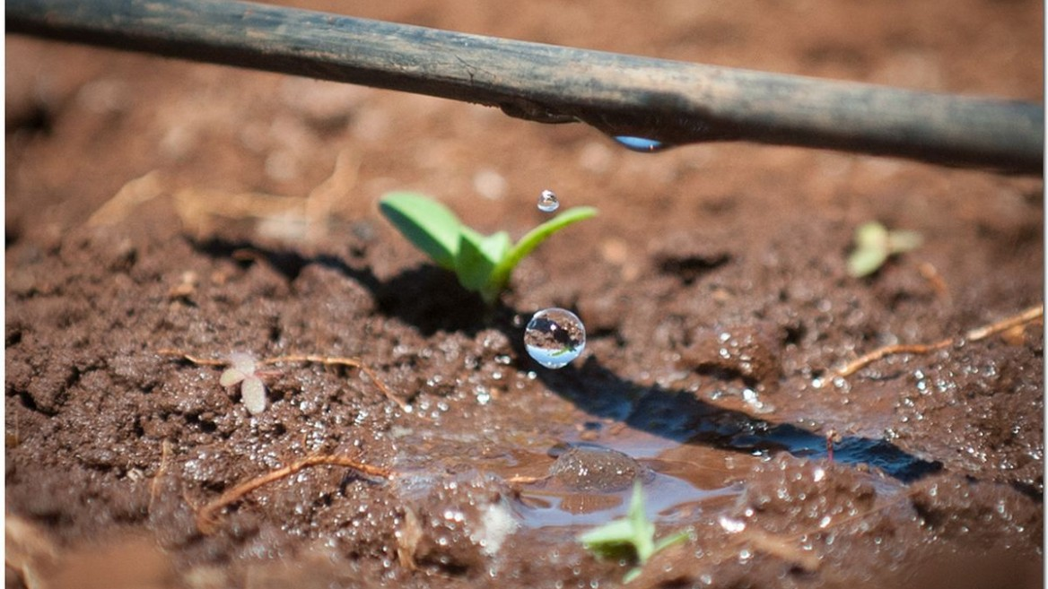

5.1 DATA REQUIRED FOR AODI SYSTEM:

The following data is required for planning and analyzing AODI System:

1. Soil Moisture of crops

2. Water requirements of crops

3. Stages in Life-time of crop

4. Water availability

5. Existing Irrigation system

6. Working of YL-69 and ESP32s

7. Services from IFTTT.

5.1.1 SOIL MOISTURE OF CROPS:

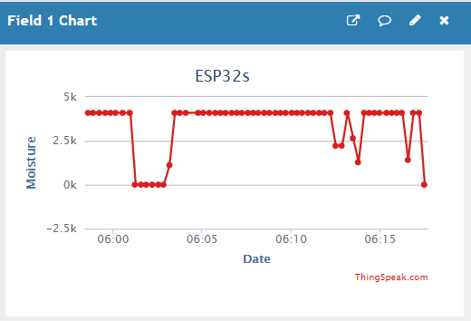

Figure 12. SOIL MOISTURE OF CROP

Soil moisture during the growing season is essential to obtain optimal yield. Optimal yield is affected by the availability of moisture as stored water in the soil profile or timely recharge during rain events. Soil texture, tillage practices, residue cover, drainage and weed control can play a significant role in soil moisture availability. Generally, the no-till system is the most effective practice in conserving soil moisture among other tillage systems, especially during dry periods in rain-fed agricultural areas.

5.1.2 WATER REQUIREMENT OF CROPS:

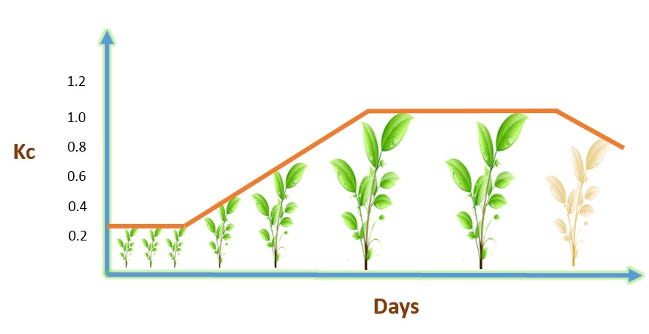

Figure 13.WATER REQUIREMENT OF CROP

The water requirement of crops is the amount of water that is required to meet the evapotranspiration rate so that crops may thrive. The evapotranspiration rate is the amount of water that is lost to the atmosphere through the leaves of the plant,

as well as the soil surface.

 Therefore, in order to estimate the water requirement of a crop we first need to measure the evapotranspiration rate. The reference rate, ET0, is the estimate of the amount of water that is used by a well-watered grass surface that is roughly 8 to 15 centimeters in height. Once ET0 is known, the water requirement of the crop can be calculated.

5.1.3 STAGES IN LIFE-TIME OF CROPS:

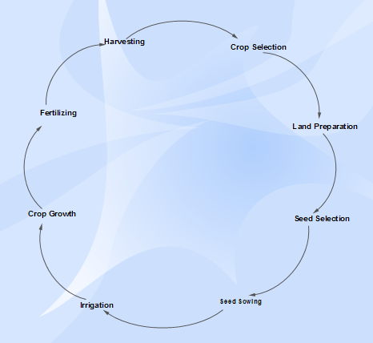

Figure 14.CROP'S LIFE STAGES

The agricultural cycle is the annual cycle of activities related to the growth and harvest of a [crop](https://en.m.wikipedia.org/wiki/Agriculture) (Plant.) These activities include loosening the soil, seeding, special watering, moving plants when they grow bigger, and [harvesting](https://en.m.wikipedia.org/wiki/Harvest), among others.

The main steps for agricultural practices include preparation of soil, sowing, adding manure and fertilizers, irrigation, harvesting and storage.

5.1.4 WATER AVAILABILITY:

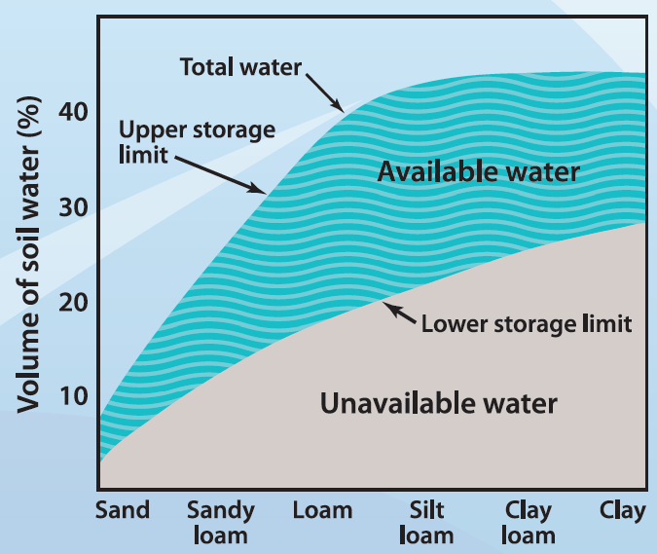

Figure 15.AVAILABLE WATER FOR CROPS

* Available water is the difference between field capacity which is the maximum amount of water the soil can hold and wilting point where the plant can no longer extract water from the soil.
* Water holding capacity is the total amount of water a soil can hold at field capacity.
* Sandy soils tend to have low water storage capacity.
* Sub-soil constraints (acidity, hardpans etc.) can prevent crops accessing water in the subsoil.
* Structure and depth of crop roots affects access to available water.

5.1.5 EXISTING IRRIGATION SYSTEM:

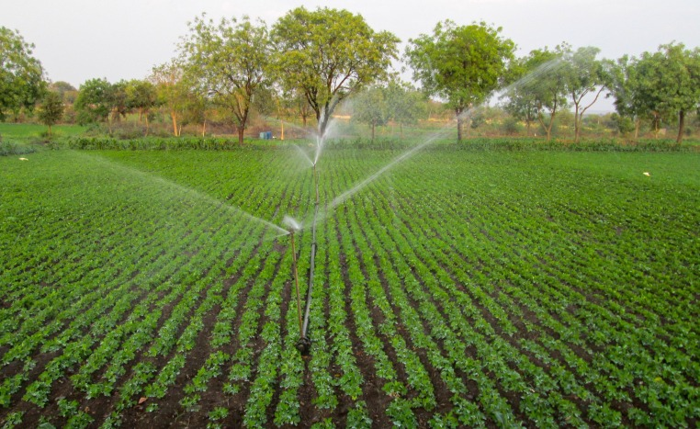

Figure 16.IRRIGATION SYSTEM

Drip irrigation is an efficient, convenient way to water your garden. It supplies the water directly to the roots of your plants, reducing evaporation and water loss through wind flow. Connect it to a timer, and your garden will water itself automatically, with minimal upkeep.Drip irrigation (sometimes called trickle irrigation) works by applying water slowly, directly to the soil, bloop, bleep, bloop, bleep. The high efficiency of drip irrigationresults from two primary factors. The first is that the water soaks into the soil before it can evaporate or run off.

5.1.6 WORKING OF SOIL MOISTURE SENSOR(YL-69) AND ESP32S:

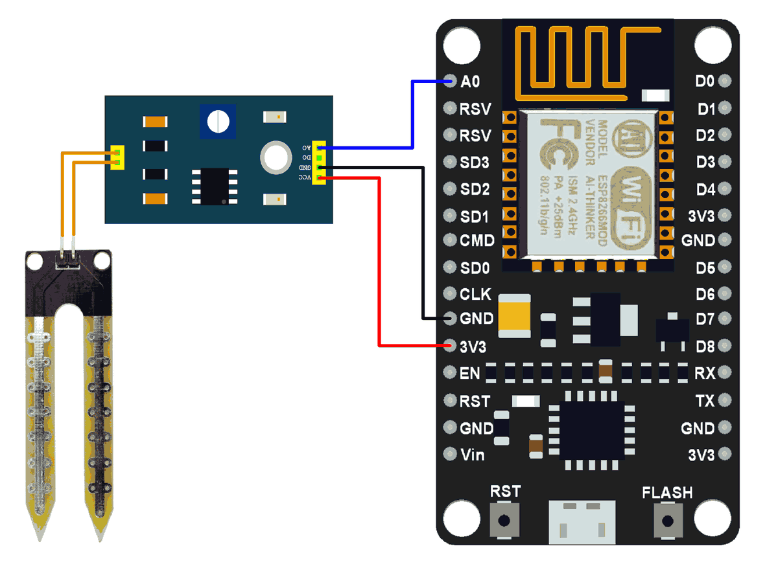

Figure 17.ESP32S AND SOIL MOISTURE SENSOR

Soil moisture is basically the content of water present in soil. This can be measured using a soil moisture sensor which consists of two conducting probes that act as a probe. It can measure the moisture content in the soil based on the change in resistance between the two conducting plates.

The resistance between the two conducting plates varies in an inverse manner with the amount of moisture present in the soil.

 The analog output of soil moisture sensor is processed using ADC. The moisture content in terms of percentage is displayed on the serial monitor.

The output of the soil moisture sensor changes in the range of ADC value from 0 to 1023. This can be represented as moisture value in terms of percentage.

For zero moisture, we get maximum value of 10-bit ADC, i.e. 1023. This in turn gives ~0% moisture.

NodeMCU ADC can be used to measure analog voltage from soil moisture sensor.

5.1.7 SERVICES FROM IFTTT:



Figure 18. SERVICES FROM IFTTT.

### IFTTT is an on-line service, that can simply act on events and create reaction. The name comes from "If this happens, then do that". The service also comes with mobile app which can receive push notifications. With 11 million users running more than a billion applets a month, IFTTT hopes to become a service that connects pretty much everything — though some users say it still has room for improvement.

CHAPTER NO. 6

“RESULTS/SCREENSHOTS”

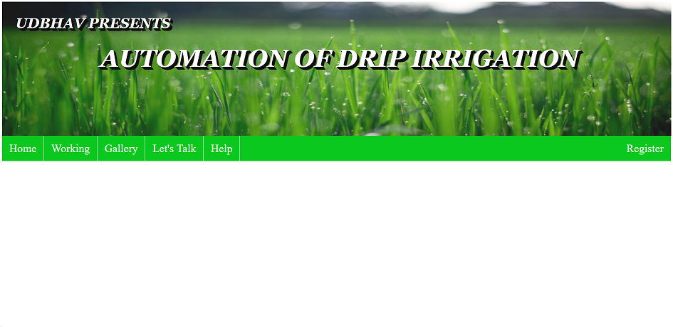

6.1 HOME PAGE:

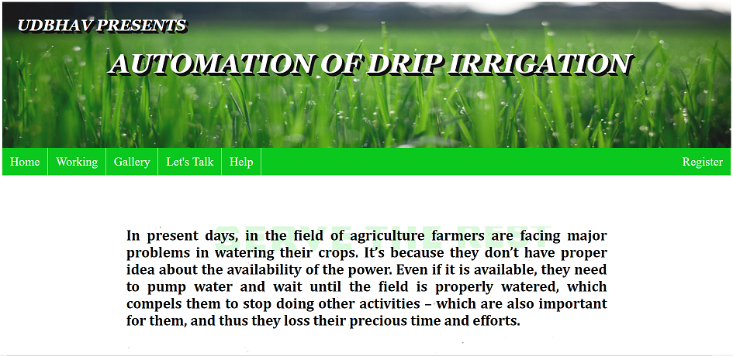

Figure 19. HOME PAGE

6.2 WORKING:

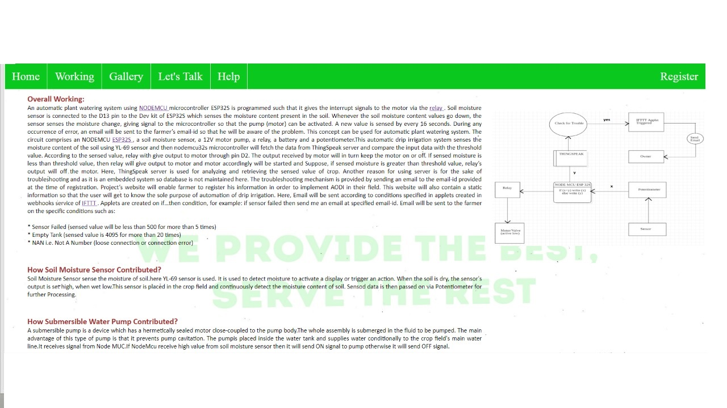

6.3 GALLERY:

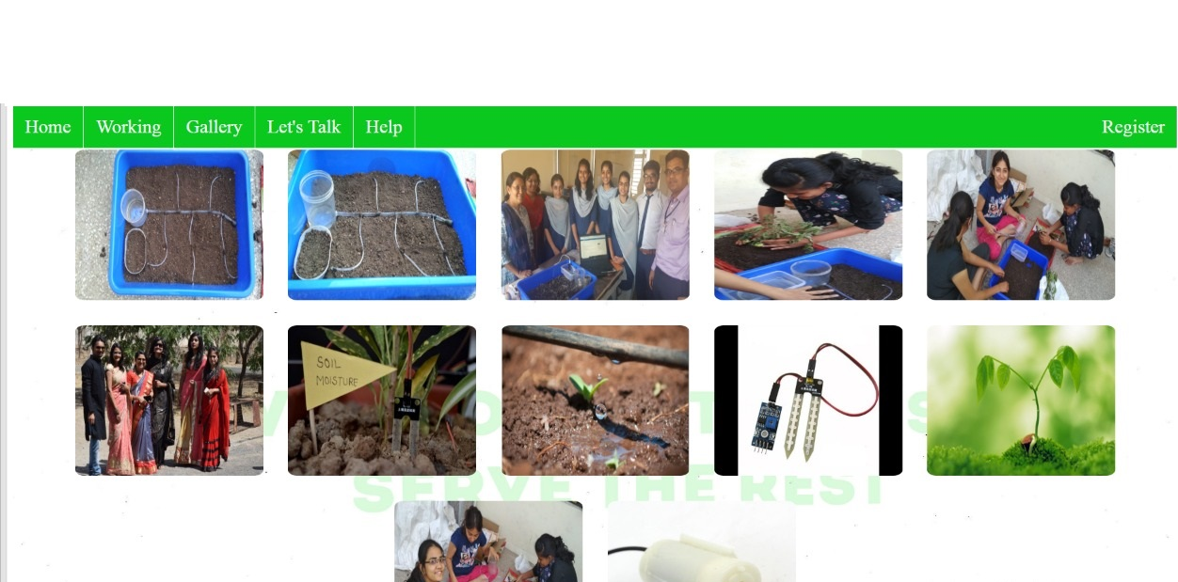

6.4 HELP:

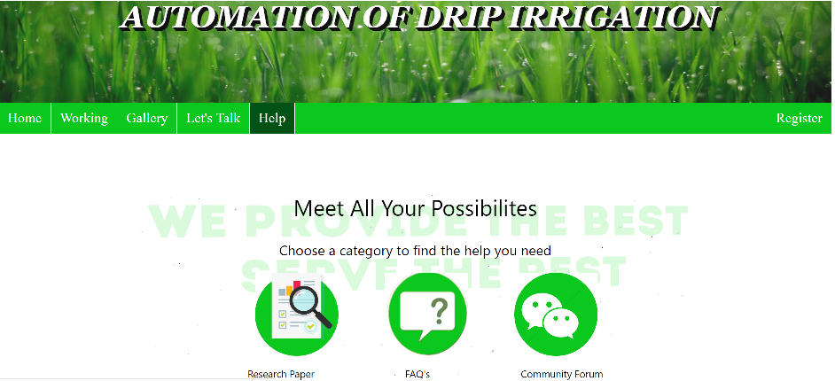

Figure 20. HELP PAGE

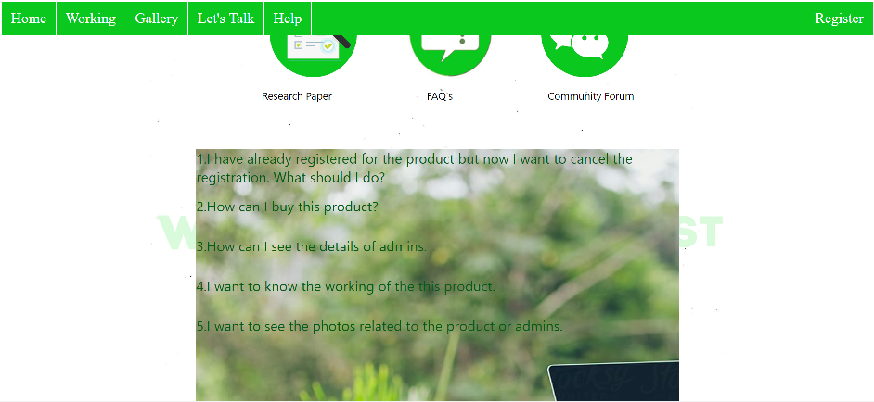

Figure 21. FAQ's

6.5 CONTACT US:



Figure 22. CONTACT US

6.6 REGISTRATION FORM:

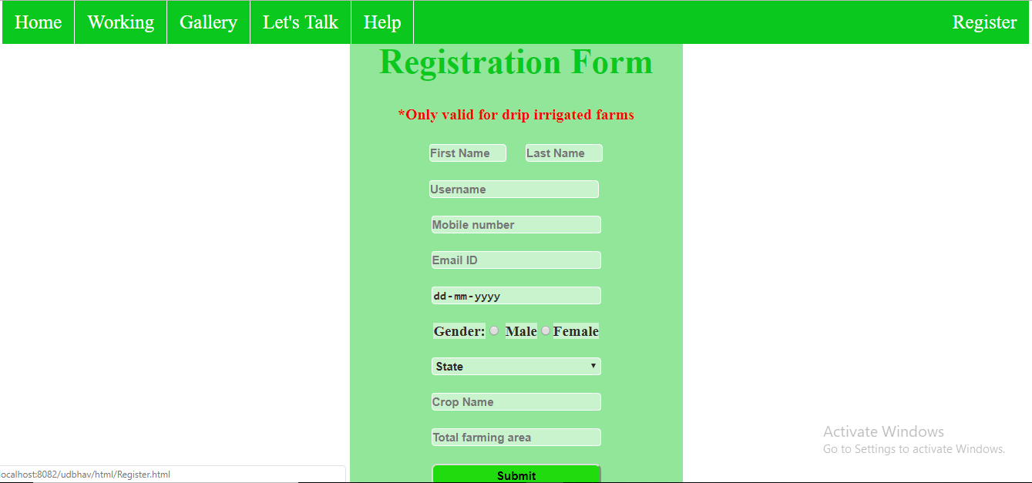

Figure 23. REGISTRATION FORM

6.7 ABOUT US:



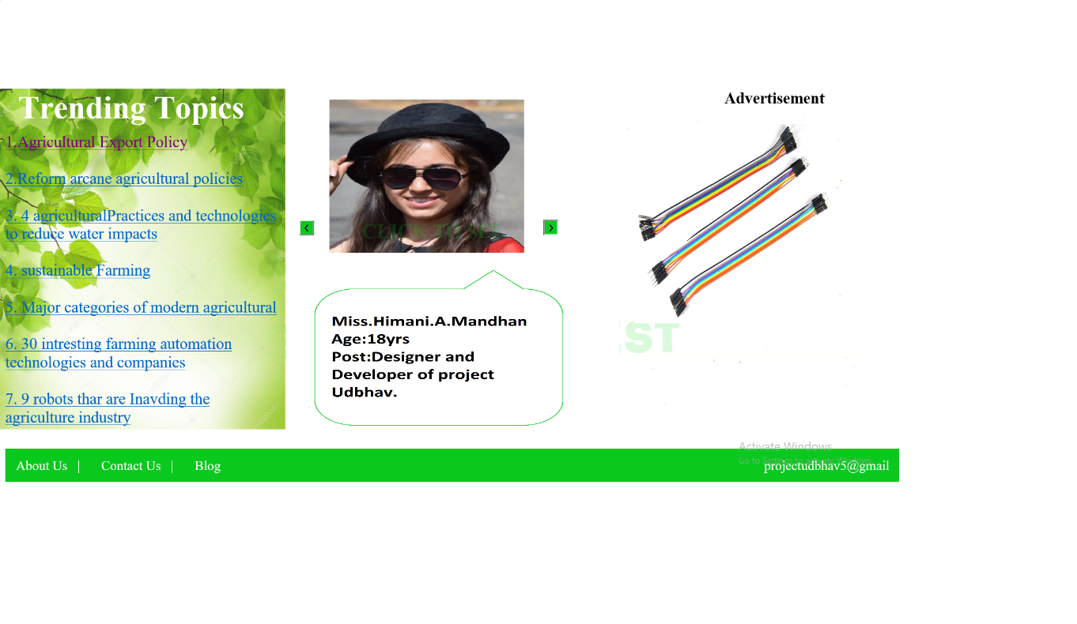

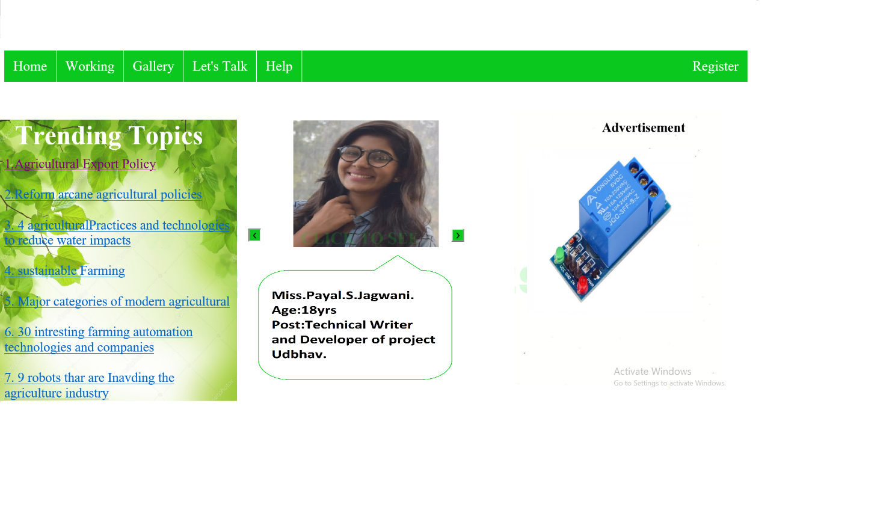

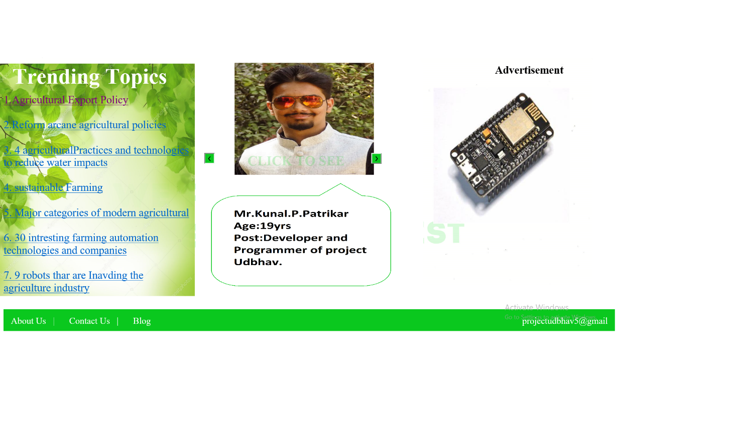

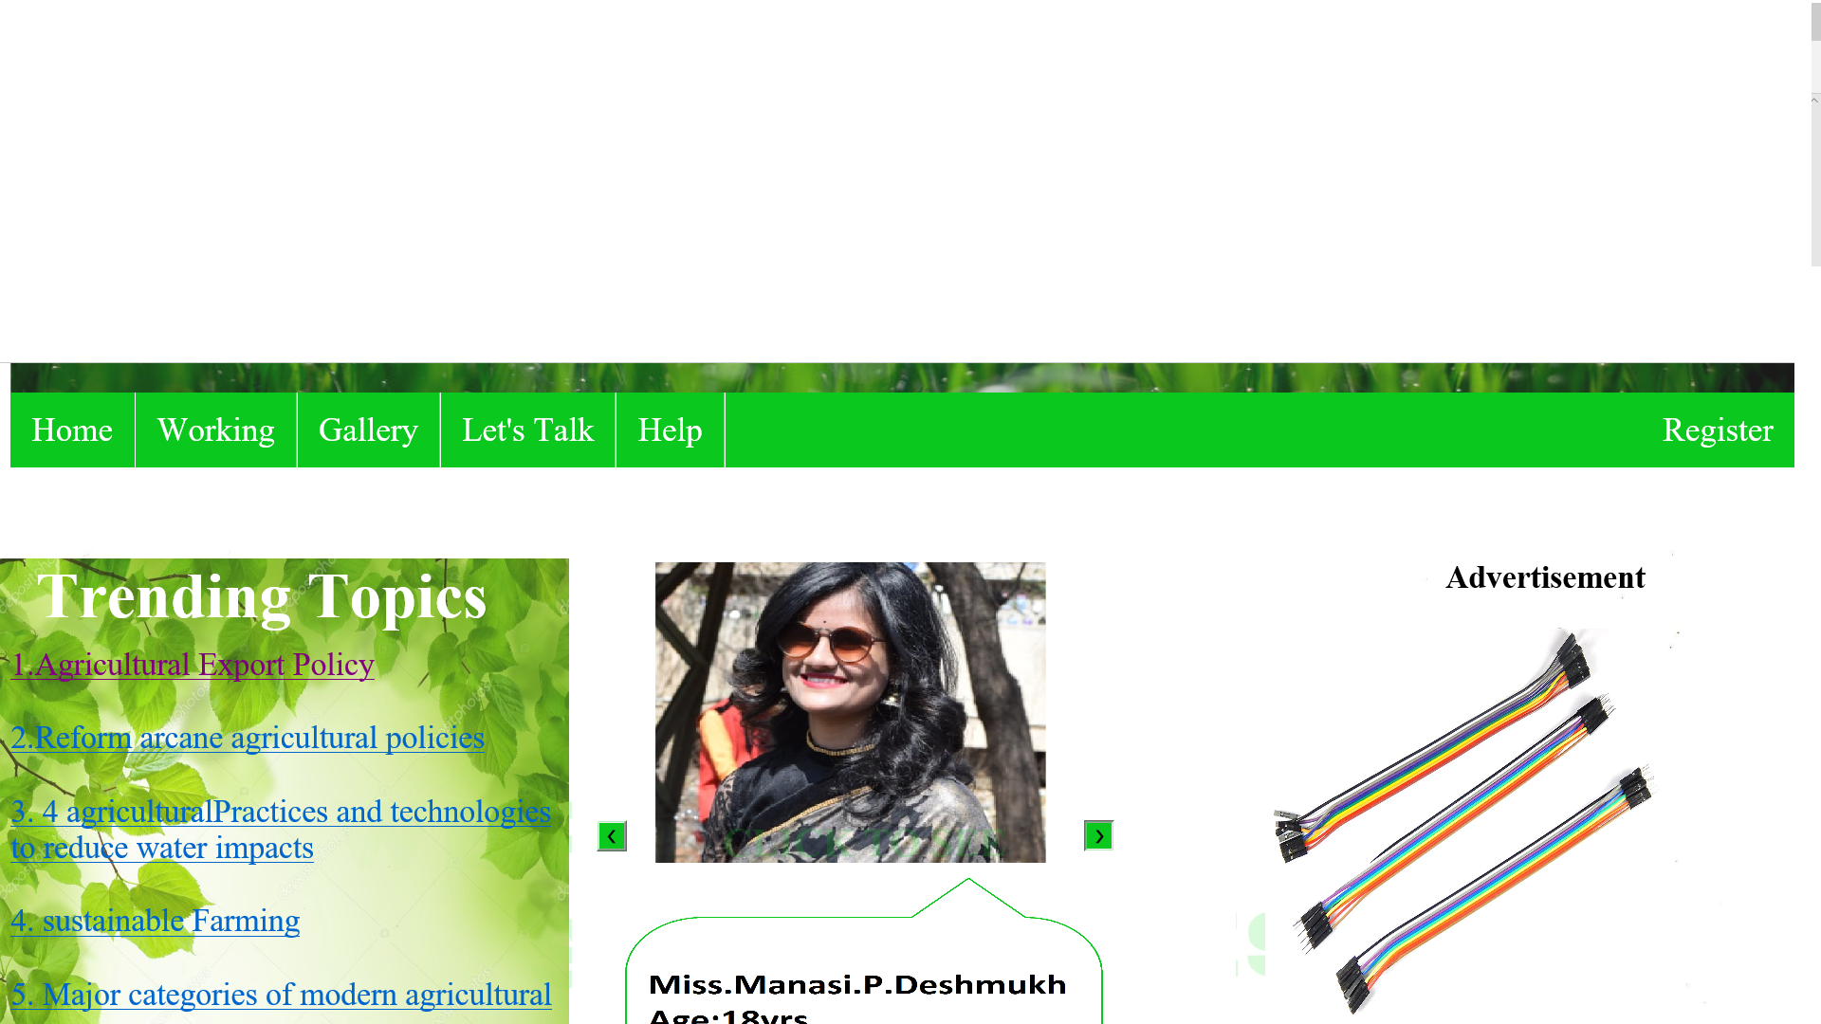

CHAPTER NO. 7

“STATEMENTS OF LIMITATIONS”

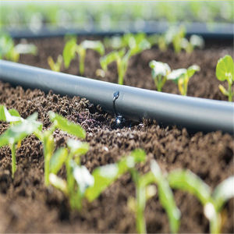

7.1 ADVANTAGES OF AODI:

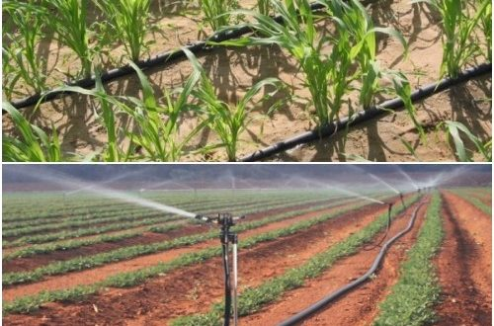

Figure 24.ADVANTAGES OD AODI

1. LOWER YOUR WATER BILL:

When you have your automated irrigation / sprinkler system installed by a professional, you ensure that:

* Water is distributed efficiently through the nozzles.
* Only areas that need water, receive it. (Your sidewalk does not need watering)
* Your lawn is watered during the ideal times by installing a timer. For instance, watering early in the morning prevents much of the evaporation and distribution by air.

All of the above adds to significant savings on your water bill over the years.

1. PREVENTS UNEVEN WATERING:

When we install **irrigation systems**, we spend a good amount of time planning the layout so that the radius of each nozzle distributes the water where it needs to go and does so evenly, preventing over or under-watering. While designing such a layout, we take into account any slopes, along with other factors, which may cause water to flow and not get properly absorbed into the soil.

While it is possible to achieve even watering with a hose, it is time consuming and not as reliable as a programmed sprinkler.

1. HEALTHY LAWN:

Like most ailments, prevention is much less costly than the cure. If you water and care for your lawn properly, you are much less likely to have to spend on replacing it or to bring it back to life. When using a hose to water your lawn, you risk the chance of uneven watering as described above. Besides causing your water to be used inefficiently, it also can case the soil to not retain nutrients, and therefore wither. A professionally-installed sprinkler system can help ensure that your soil and thus your lawn continue to be healthy.

1. TROUBLESHOOTING MECHANISM:

Troubleshooting is managed properly i.e. every occurrence of error will send an email to the farmer indicating to be aware from the error occurred. This mechanism is provided by the IFTTT services which in turn contain thousands of services such as webhooks, SMS, twitter.

*ADDITIONAL BENEFITS:

In addition to reducing the cost of your water bills and keeping your lawn healthy, the right automated irrigation system can help increase the value of your home, as well as save you time.  Most new home buyers today are expecting a home with amenities like the irrigation system. They are not looking to spend 2 – 5 hours a week watering their home with a hose, and that is most likely the time you would like to get back into your life as well!

7.2 WEAKNESS OF AODI:

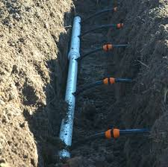

Figure 25.WEAKNESS OF AODI

* High initial investment requirements;
* Regular capital requirement for replacement of drip irrigation equipment on the surface (damage due to movement of equipment, UV-radiation);
* Drip irrigation emitters are vulnerable to clogging and dysfunction (water filters required, regular flushing of pipe system);
* High skill requirements for irrigation water management in order to achieve optimal water distribution;
* Soil salinity hazard.

7.3 ALTERNATIVES OF AODI:

7.3.1 AUTOMATIC IRRIGATION SYSTEM USING ANDROID:

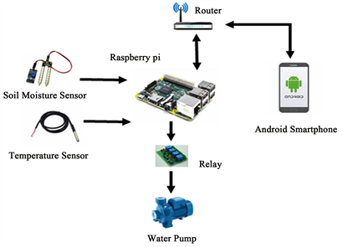

Figure 26.AUTOMATED IRRIGATION SYSTEM USING ANDROID

An Android based Automatic Irrigation System using a WSN and GPRS Module is presented. The user communicates with the Arduino microcontroller through SMS. Android automatic system is developed, it displays the values of the sensors continuously in an android application and on a web page and user can control the motor pump ON/OFF from any place, while user receives an SMS alert through GSM/GPRS module.

The system has a soil moisture and temperature sensor. Each wireless sensor node was comprised of a soil moisture probe, a temperature sensor probe, a microcontroller for acquisition of data, and a radio transceiver. The receiver unit comprises a master microcontroller, radio transceiver, GSM and a pump. The communication link between the transmitter and receiver units is via the ZigBee protocol. Irrigation scheduling could be monitored using an Android Application. This system conserves electricity by reducing the usage of grid power and cost-effective solar power can be the answer for all energy needs. It can be a suitable alternative for farmers in the present state of energy crisis. It optimizes the usage of water by reducing wastage and reduces the human intervention for farmers.

The aim of this study was to control devices and monitor the system remotely through a web page.

7.3.1.1 PROPOSED BLOCK DIAGRAM:

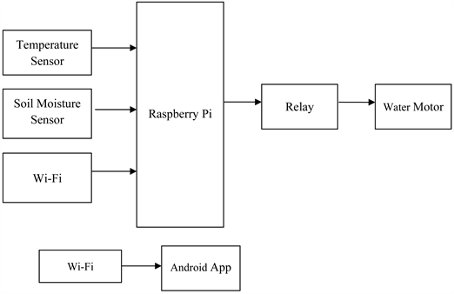

Figure 27.DATA FLOW DIAGRAM OF ANDROID BASED IRRIGATION

The overall block diagram of Raspberry Pi based automatic irrigation system which consist of two sensors connected to controller and the values from these sensors send to Android application. This various monitoring and controlling system can be utilized where automation of agricultural parameters like temperature and soil moisture are monitored and control by the system.

* SOIL MOISTURE SENSOR**:**

The soil moisture sensor is used to measure the volumetric water content of soil. It is used to monitor soil moisture content to control irrigation in greenhouse. A moisture sensor is used to sense the level of moisture content present in irrigation field. It has a level detection module in which we can set a reference value.

* TEMPERATURE SENSOR(LM35):

The LM35 series are precision integrated-circuit temperature devices with an output voltage linearly-proportional to the Centigrade temperature. The LM35 device has an advantage over linear temperature sensors calibrated in Kelvin, as the user is not required to subtract a large constant voltage from the output to obtain convenient Centigrade scaling.

* RASPBERRY PI:

The Raspberry Pi is a low cost, credit-card sized computer. Its capable of doing everything you’d expect a desktop computer to do, from browsing the internet and playing high-definition video, making spreadsheets, and playing games. There are different models of Raspberry Pi from Raspberry Pi 0 to Raspberry Pi 3. In this project we are using Raspberry Pi Model 1 B+.

* RELAY:

The relay module is an electrically operated switch that allows you to turn on or off a circuit using voltage and/or current much higher than a microcontroller could handle.

* WI-FI:

The Wi-Fi makes Internet of things devices cable free. Specifications:

1) Wireless Standards: IEEE 802.11n, IEEE 802.11g, IEEE 802.11b

2) Frequency Band: 2.4/5 GHz Dual Band

3) Data Rate: 802.11ac: wireless transmission rate up to 300 M + 300 M

* ANDROID APPLICATION:

Android is a mobile operating system developed by Google, based on a modified version of the Linux kernel and other open source software and designed primarily for touch screen mobile devices such as smart phones and tablets. In addition, Google has further developed Android TV for televisions, Android Auto for cars and Android Wear for wrist watches, each with a specialized user interface. Variants of Android are also used on game consoles, digital cameras, PCs and other electronics.

7.3.1.2 WORKING:

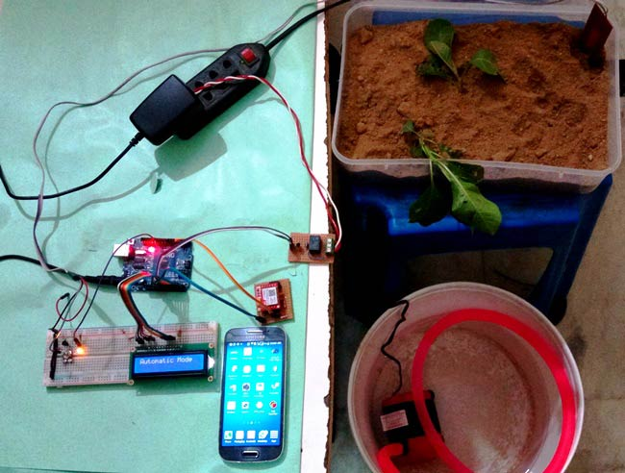

Figure 28.WORKING OF ANDROID BASED IRRIGATION

It consists of different types of sensing units such as Soil moisture sensor to measure water content of soil, temperature sensor to detect the temperature.

The android based on an automatic irrigation system which performs multiple operations in the field of agriculture, this project uses a Raspberry Pi microcontroller which is programmed to receive the input signal of multiple sensors of the field. One Raspberry Pi microcontroller receives this signal; it generates an output that drives a relay for operating the water pump.

If user sees the soil moisture value is below the threshold or the temperature exceeds the threshold value then the user will turn on motor through an Android application until the levels of moisture and temperature are optimized and then turn off motor. Android mobile operating system is interfaced with the Raspberry Pi microcontroller to control the parameters of the field. The soil moisture and temperature sensor insert into the field. Connections from the soil moisture and temperature sensor are interfaced to the microcontroller. This signal is sent to mobile which displays the sensor values and switch ON/OFF to user.

7.3.1.3 ADVANTAGES:

The design is low cost in terms of hardware component this system avoids over use of water in irrigation, under irrigation and reduces the wastage of water and it can be implemented in large agricultural areas. The system helps in labor problem when there are no labors to work and eliminates man power. This system can be operated automatically as well as manually.

# 7.3.1.2 AUTOMATED IRRIGATION SYSTEM USING CAYENNE:

# 

Figure 29.CONTROL PANEL OF CAYENNE

# This project was created in order to be able to have full control of our irrigation from anywhere with a simple Internet connection using the **My Devices Cayenneplatform**. Also, since these days saving water is important a drip system will help. I thank the developers of this platform as we facilitate the creation of new projects, in just a few minutes.

Within this control panel we have all the necessary control of our irrigation system, both Raspberry Pi, Arduino, relays, PIR sensor, LCD, etc.

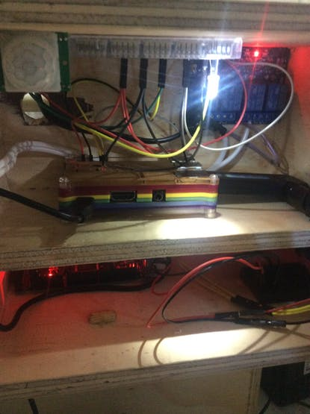

Figure 30.WORKING OF CAYENNE

Within this simulator there is a valve which actuates the flow of water, this valve is connected to the control panel.

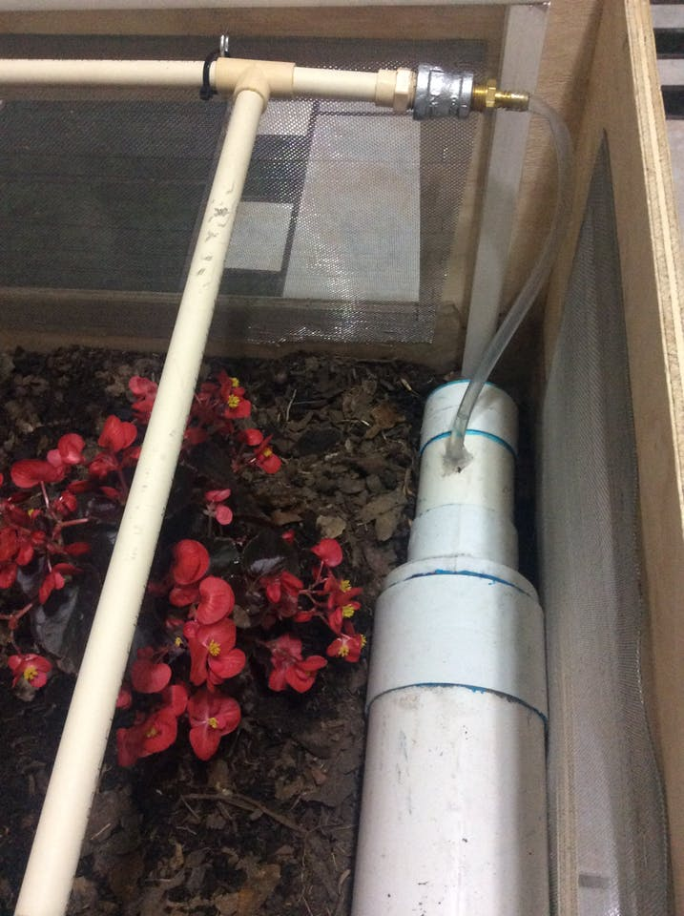

Figure 31.CAYENNE SYSTEM

CHAPTER NO. 8

“CONCLUSION”

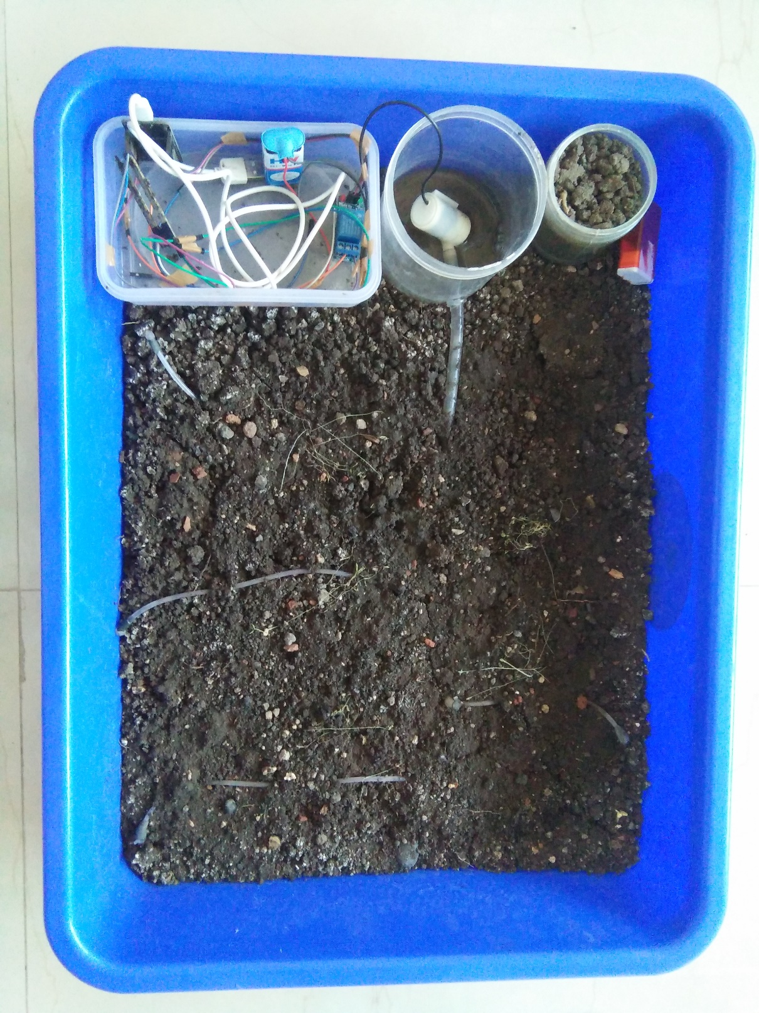

* 1. IMPORTANCE OF AODI SYSTEM:

All systems of automation have advantages and disadvantages that need to be considered when deciding which system will suit the irrigation layout for a particular property. There is no system that will be the "best" system for all properties.

The methods of irrigation used by the irrigator need to be considered. If a system that can be moved around the property and perhaps used on other properties is required, then the irrigator needs to consider those systems that are portable. If the irrigator wants a system where the components are fixed and can follow the same irrigation sequence each irrigation, then a fixed system would be more appropriate.

In determining the best system for a property, the irrigator will need to consider the cost of the system, back up servicing of the system and which system will best suit the property and irrigation layout.

Drip irrigation is a type of [micro-irrigation](https://en.m.wikipedia.org/wiki/Micro-irrigation) system that has the potential to save water and nutrients by allowing [water](https://en.m.wikipedia.org/wiki/Water) to drip slowly to the [roots](https://en.m.wikipedia.org/wiki/Root) of plants, either from above the [soil](https://en.m.wikipedia.org/wiki/Soil) surface or buried below the surface. The goal is to place water directly into the [root zone](https://en.m.wikipedia.org/wiki/Rhizosphere) and minimize [evaporation](https://en.m.wikipedia.org/wiki/Evaporation). Drip irrigation systems distribute water through a network of [valves](https://en.m.wikipedia.org/wiki/Valve), [pipes](https://en.m.wikipedia.org/wiki/Pipe_(fluid_conveyance)), [tubing](https://en.m.wikipedia.org/wiki/Tube_(fluid_conveyance)), and [emitters](https://en.m.wikipedia.org/wiki/Drip_irrigation#Emitter). Depending on how well designed, installed, maintained, and operated it is, a drip irrigation system can be more efficient than other types of irrigation systems, such as [surface irrigation](https://en.m.wikipedia.org/wiki/Surface_irrigation) or sprinkler irrigation.

* 1. CONTRIBUTIONS OF AODI SYSTEM:

CONTRIBUTIONS OF AUTOMATED DRIP IRRIGATION SYSTEM INVOLVES:

### 1.REDUCED LABOUR:

As the irrigator is not required to constantly monitor the progress of an irrigation, the irrigator is available to perform other tasks – uninterrupted.

### 2.IMPROVED LIFESTYLE:

The irrigator is not required to constantly check the progress of water down the bays being irrigated. The irrigator is able to be away from the property, relax with the family and sleep through the night.

* **MORE TIMELY IRRIGATION:**

 Irrigators with automation are more inclined to irrigate when the plants need water, not when it suits the irrigator.

* **ASSISTS IN THE MANAGEMENT OF HIGHER FLOW RATES:**

Many irrigators are looking to increase the irrigation flow rates they receive through installing bigger channels and bay outlets. Such flow rates generally require an increase in labor as the time taken to irrigate a bay is reduced thus requiring more frequent change over. Automation allows for these higher flows to be managed without an increase in the amount of labor.

* **MORE ACCURATE CUT-OFF:**

 Automation of the irrigation system allows cut-off of water at the appropriate point in the bay. This is usually more accurate than manual checking because mistakes can occur if the operator is too late or too early in making a change of water flow.

* **REDUCED RUNOFF OF WATER AND NUTRIENTS:**

 Automation can help keep fertilizer on farm by effectively reducing run off from the property. Retaining fertilizer on farm has both economic and environmental benefits.

* **REDUCED COSTS FOR VEHICLES USED FOR IRRIGATION:**

As the irrigator is not required to constantly check progress of an irrigation, motor bikes, four wheelers and other vehicles are used less. This reduces the running costs of these vehicles and they require less frequent replacement.

CHAPTER NO. 9

“REFERENCES”



1. http://www.circuitstoday.com/automatic-irrigation-system-arduino

2.https://www.researchgate.net/publication/321018656_DESIGN_OF_EMBEDDE D_SYSTEMS_FOR_THE_AUTOMATION_OF_DRIP_IRRIGATION

3. https://docs.zerynth.com/latest/official/board.zerynth.nodemcu_esp32/docs/index.html

4. https://www.researchgate.net/publication/283725314_An_Automated_Drip_Irrigation_System_Based_on_Soil_Electrical_Conductivity